Steps and Pre requirements to run locally the solution for InvestmentX Company

1) Install AWS CLI

Go to the following link (https://docs.aws.amazon.com/es\_es/cli/latest/userguide/getting-started-install.html) and download the [**https://awscli.amazonaws.com/AWSCLIV2.msi**](https://awscli.amazonaws.com/AWSCLIV2.msi) file.

Run the wizard to install AWS CLI.

2) Configure AWS CLI

To configure an AWS CLI you will need to create a user in AWS with the following set of permissions:

\*[AmazonDynamoDBFullAccess](https://us-east-1.console.aws.amazon.com/iam/home" \l "/policies/arn%3Aaws%3Aiam%3A%3Aaws%3Apolicy%2FAmazonDynamoDBFullAccess" \t "'_blank')

\* [AWSLambda\_FullAccess](https://us-east-1.console.aws.amazon.com/iam/home#/policies/arn%3Aaws%3Aiam%3A%3Aaws%3Apolicy%2FAWSLambda_FullAccess)

\* [AmazonAPIGatewayInvokeFullAccess](https://us-east-1.console.aws.amazon.com/iam/home#/policies/arn%3Aaws%3Aiam%3A%3Aaws%3Apolicy%2FAmazonAPIGatewayInvokeFullAccess)

\* [AmazonS3FullAccess](https://us-east-1.console.aws.amazon.com/iam/home#/policies/arn%3Aaws%3Aiam%3A%3Aaws%3Apolicy%2FAmazonS3FullAccess)

Run the following promp command

* aws configure

Set the AWS Access key ID and AWS Secret Access Key

3) Install SAM

https://docs.aws.amazon.com/serverless-application-model/latest/developerguide/serverless-sam-cli-install-windows.html

4) Install docker

5) Install Python3.9 version

6) Create dynamo tables

To create AvailableSymbols table run the following command on CLI

aws dynamodb create-table --table-name AvailableSymbols --attribute-definitions AttributeName=InterestedSymbols,AttributeType=N --key-schema AttributeName=InterestedSymbols,KeyType=HASH --provisioned-throughput ReadCapacityUnits=5,WriteCapacityUnits=5 --table-class STANDARD

To create SymbolsPrices table run the following command on CLI

aws dynamodb create-table --table-name SymbolsPrices --attribute-definitions AttributeName=searchdate,AttributeType=S --key-schema AttributeName=searchdate,KeyType=HASH --provisioned-throughput ReadCapacityUnits=5,WriteCapacityUnits=5 --table-class STANDARD

7) create S3 bucket

aws s3api create-bucket --bucket testinvestmenxbucket --region us-east-1

note: you should change this name in the variable BUCKET\_NAME in code if the bucket name is not available.

8 Test Lambda steps

Clone repository (https://github.com/JoseMauricioGilBello/InvestmentXCompany.git)

Open terminal and write the following command

* Build sam

If you want to test the lambda you can run the following commands

1 UserStory (As a trader I want to know which symbols are available to be configured so I can know which ones I can use.)

* sam local invoke InvestmentX -e InvestmentXCompany/test/getsymbols.json

2 UserStory (As a trader I want to configure which symbols I’m interested on and which ones I’m not so I can view their prices later accordingly.)

* sam local invoke InvestmentX -e InvestmentXCompany/test/configloadprices.json

3 UserStory (As a trader I want to know the available prices for a specific stock in a given timeframe so I can further analyze the data.)

* sam local invoke InvestmentX -e InvestmentXCompany/test/ getspecificprice.json

4 UserStory (As a trader I want to download all data from all stocks in a csv format so I can open it in third-party software like Microsoft Excel or Google Sheets.)

* sam local invoke InvestmentX -e InvestmentXCompany/test/downloadcsv.json

to test the api gategate run the following command

sam local start-api

once you get the url

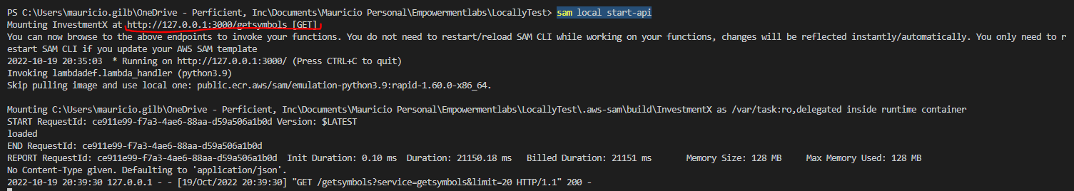

You can configure postman.

Open postman and import the file InvestmentX.postman\_collection.json attached on the email sent and also located in the repository docs folder.

Once imported you should change the url for each service by the url obtained in the previous step.

Example

Before

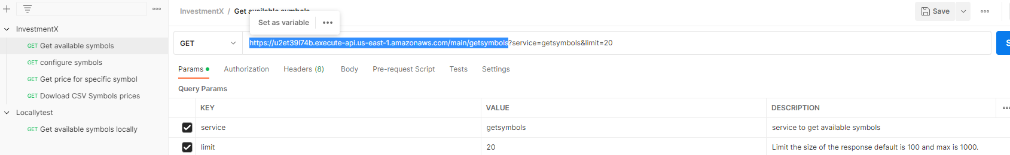

After

Finally, you can test all the service al shown in the loom video.